An Introduction to ΔE* (Delta E* or dE*)

Sports fanatics (“fans”) love to pore over statistics. There are efficiency metrics, error metrics, possession metrics, and a myriad of others. In fact, for American Baseball, there is even an entire society of fans dedicated to revising old statistics and inventing new ones. Ultimately what determines success, though, is the scoreboard; who won and who lost.

Like sports, display calibration can generate a huge number of statistics: on/off contrast ratio, ANSI contrast ratio, modified ANSI contrast ratio, nominal light output, calibrated light output, just to name a few. While most of these are important in one context or another, the most important statistic, the one that governs when the game is over, is color error. This is otherwise known as Delta E.

The Summer of Luv
In 1976, the Commission Internationale d’Eclairage (CIE) revamped the original 1931 xyY Cartesian system in order to make the coordinate system perceptually uniform. What they came up with were two new methods of describing color:
- CIE Lab – is a color space used for subtractive colors (e.g., print and textiles), and
- CIE Luv - is a color space used for additive colors (e.g., film and video).
While CIE Lab is important in the textile industry (and shows up a little later for video), the real story for video and film is the CIE Luv (“sea love”) color space. The L (really L*) component is a measure of the quantity of light, called lightness. The u and v components are most easily thought of as transforms of the original 1931 x and y axes.

Note: you will often see uv written as either u’v’ or u*v*. The difference between the two is that u*v* is essentially u’v’ scaled up or down by L*.

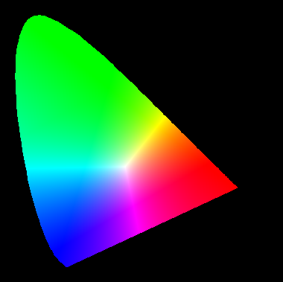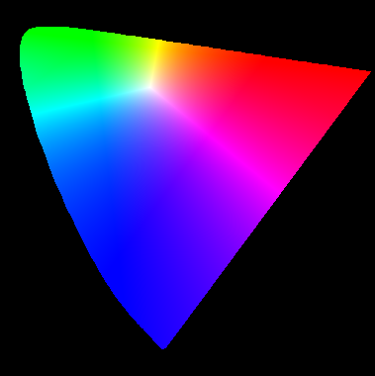
Figure 1. Hypothetical color gamuts using the xy (left) and uv (right) color coordinate systems. The actual colors depend significantly on the output device.

The use of the uv coordinate system highlighted a major shortcoming in the old xy system. The human visual system is much more sensitive to slight changes in the color blue than in either green or red. However, looking at the 1931 “shark fin” diagram, this concept is subsumed by the overly large section that is what we would best classify as being “green”.

With a formal standard in place for perceptual uniformity, the CIE was also able to formalize a method for representing color error called ΔE*. This is often written as Delta E*, dE* or just simply dE. Delta E* is the three-dimensional geometric distance between two points, typically a target or ideal and an actual. Even though it is three-dimensional, Delta E* is typically thought of as having two components:
- dL* - this is portion of the color error attributable to differences in the quantity of light, and
- dC* - this is the portion of the color error attributable to differences in the quality of light. It is often talked about as the chroma error, though chroma has a very specific meaning for video signals.

Gamma Error
Since dL* is the component of color error that represents differences in the quantity of light, some portion of this value is attributable to differences between the target gamma and the display’s actual gamma. In other words, since Delta E* measures the distance between two points, if your actual gamma curve varies significantly from your target curve, it will have a significant amount of error in it that results from this mismatch in gamma. By default, CalMAN uses an option where Delta E* values are presented with this error factored out. If you want to see the raw color error, simply uncheck the option for gamma correction.

A note on Black Level Compensation: don’t use it. CalMAN includes black level compensation solely for compatibility purposes for users trying to compare results they achieved with CalMAN to results from another calibration package. It serves no useful purpose other than this, and beyond this, it only hides potential issues in your display.

Let’s Make a Sequel
In color error, as in Hollywood, if the first one played well, then obviously you should make a sequel. In this case, the debate raged for almost 20 years (18, to be exact) about the shortcomings of Delta E*. In 1994, a new equation, based upon the CIE Lab color space, was ratified that further broke out a hue component from the old dC*.

For video calibration, this is especially useful when calibrating the color decoder of your television. Instead of guessing which of the classic saturation or hue controls needed to be changed more, now there was a guide. The utility of this breakdown is dealt with more extensively in the topic on Color Decoders, however, what is important for this narrative is that we now have two formulae for computing Delta E*, and they do not return the same values every time. What is an international commission to do?

Delta E*, part III – Payback Time!
As with Hollywood, if the first sequel does well, that means that we should do another sequel. In 2000, the CIE further refined the color error equation, adding in an interaction effect between saturation and hue. Interpreting this latest twist is a real challenge. The film and video industry should have cried when the neatly packaged 1994 equation was superseded, but few of them actually noticed. Instead, most people still use the 1976 formula.

Delta E*, jr.
As if three different equations for color error were not enough, a fourth has come into popular use, though it is not a formally acknowledged standard. Instead, it is an analytical convenience to achieve a similar desired outcome as what CalMAN does with gamma correction. This flavor of color error known as “Delta E* u*v*”, or dEuv for short, sets L* to 100 for all measurements, whether that is a logical thing to do or not. This does eliminate the influence of the actual light measurement from the calculation of color error, but it also has the tendency to overestimate the total color error for anything other than pure white.

Due to the power of the analytical convenience, CalMAN uses the dEuv formula extensively in the Basic user profile. However, Intermediate or Advanced users are advised to use either the 1994 or 2000 formulae to calibrate.

Taking it to the Max
Because the 1976, 1994 and 2000 formulae all produce slightly different results given the same input, CalMAN includes a “dEmax” formula that shows what the maximum color error is for any given measurement point using all three formula. This provides users the hardest reasonable metric to ensure that color error really is not visible.

The goal for moving pictures, where there is not a color-accurate reference next to the image, is to have color error be less than 4 for all measurement points.

What’s in a Reference?
If you are calibrating a full grayscale, typically 11 point and up, one of those points will end up representing white, and it will act as the reference against which all of the other points are scaled. However, when you are measuring or calibrating the color gamut, there is not necessarily an explicit step to measure a 100% white pattern, especially if you are using the typical 75% patterns. However, to calculate the color error properly, CalMAN needs a white point reference.

To use anything other than the dEuv formula with the color gamut, display a 100% white pattern, move the slider to 100%W and take a reading.

The Society for American Baseball Research (or SABR), if you are curious. It is from this group that a discipline known as “sabermetrics” has arisen.

